🟢 Bandit Level 9 → Level 10
The password is in data.txt.
The clue says it is one of the human-readable strings, preceded by several = characters.
✅ Step 1: Check the file
Ls
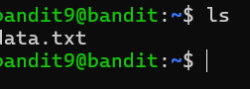
✅ Step 2: Extract readable strings
strings data.txt
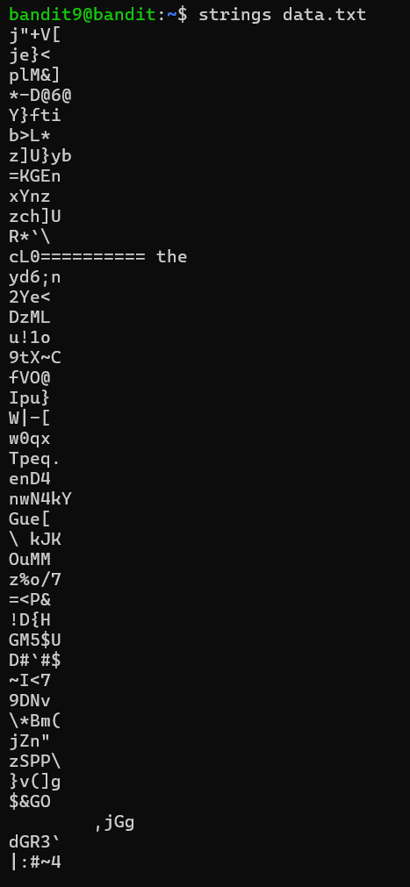
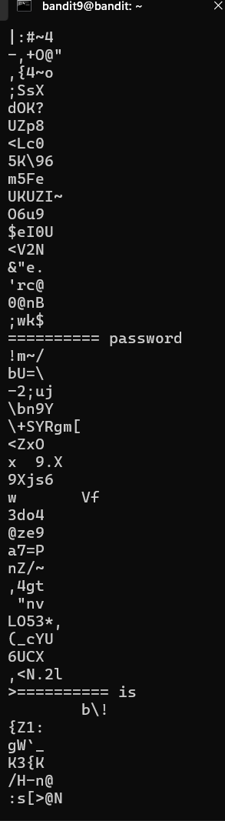
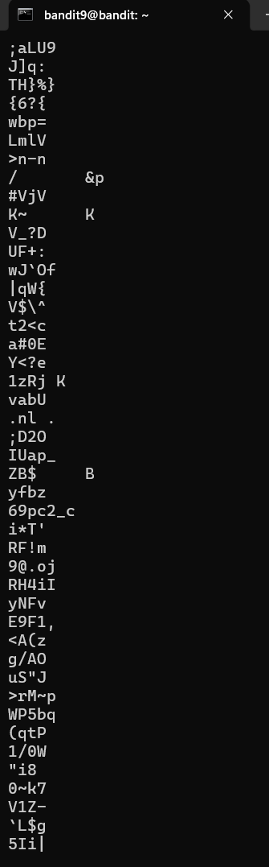
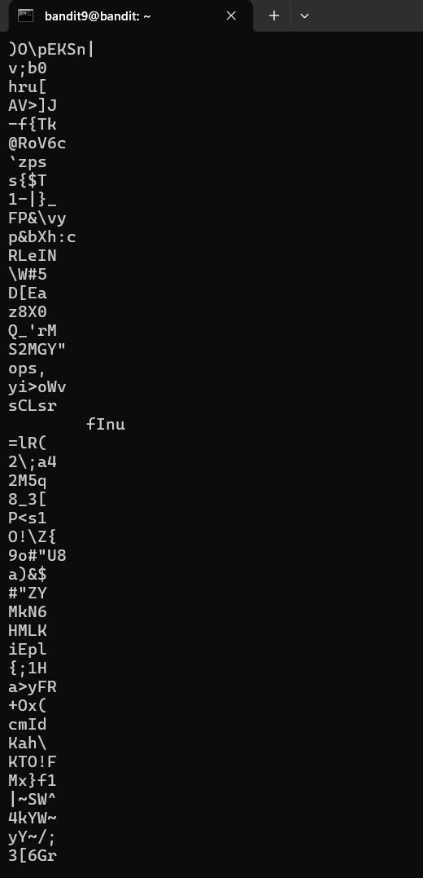
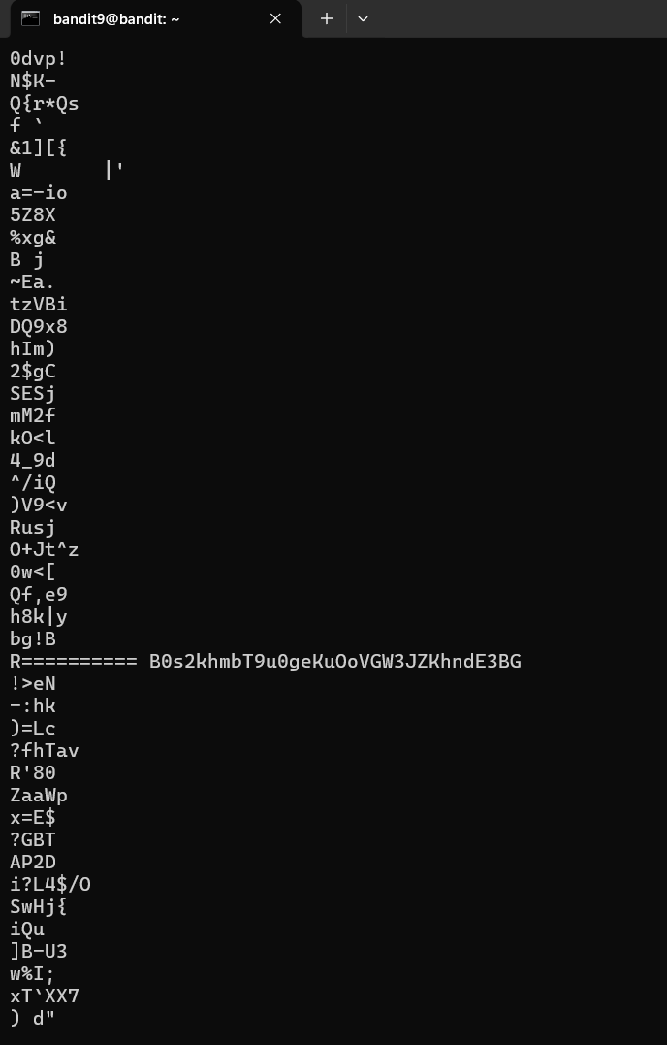
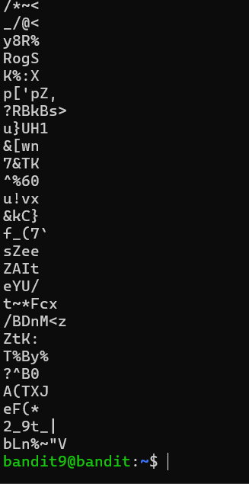
A quicker command is:
strings data.txt | grep "=="
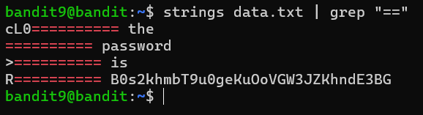
🔑 The relevant output contains the password for bandit10.
Then exit from that level

